NAAN MUDHALVAN

INTRODUCTION:

* 1. Overview

The primary goal of the Tamil Nadu Naan Muduhalvan scheme is to identity train and provide carrier and academic guidance to the students and state run educational institution our project course. Topic design with canva. In this course we have done empathy mapping and brainstorming. The empl\athy mapping process help as to distill amd categorize. In Empathy map we included says, Think, Feels, Does.

Say- I want something reliable. Thinks- What else am I missing. Feels- Excited.

Does- More search.

The goal of Braintorning s to generate many ideas quickly and its help us to think out of the _box. The ideas are discussed our group members to merge and refined

* + 1. project management – Alternative ideas, business
    2. Human capital – Decision making, root causes Alternative
    3. Team building – stare discussion, communication skill
    4. Improver – profitability, initiative
  1. Purpose

Canva is an online design tool that offers users the opportunity to create professional

– looking posters, slideshows, images, event flyers, resumes, card, certificated, infographics, and other media. The tool allows students to design visuals to showcase their knowledge in unique ways.

PROBLEM DEFINITION & DESIGN THINKING

* 1. Empathy Map

We discuss our group to collect the ideas create the project the empathy map Emily B to our

Group members dicussel

Say –I want something reliable. Thinks- What else am I missing. Feels- Exited.

Does- More search.

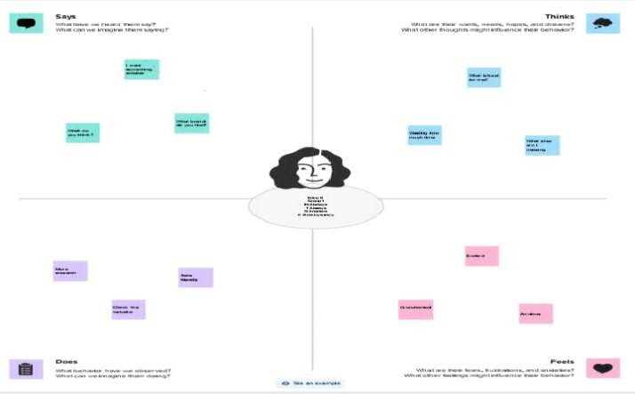

* 1. Ideation & Brainstorming map

We discuss our group to ollect the ideas create the project the Brainstorming map Group members discussel

Say- I want something relible Thinks-What else am I missing Feels-Exited

Does- More search

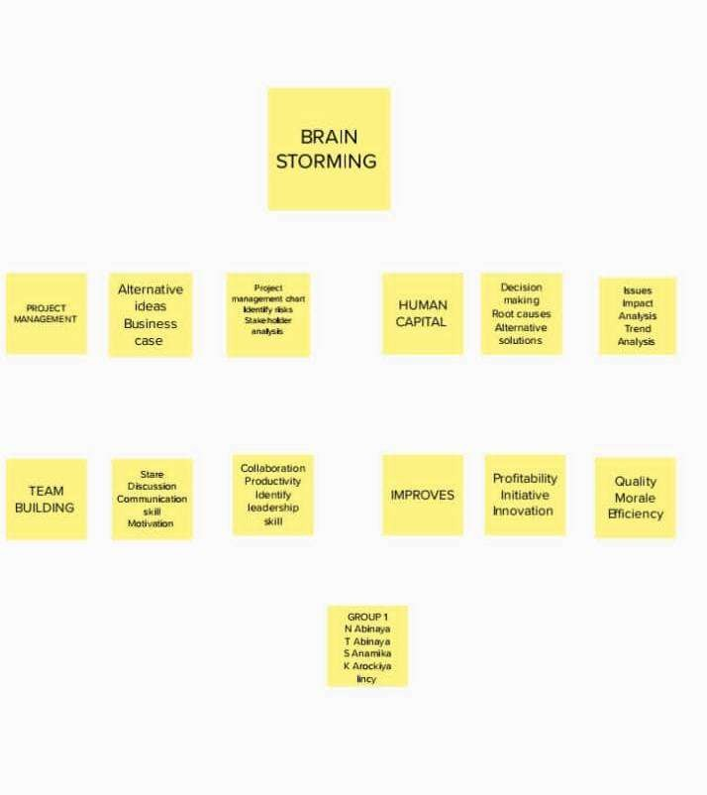

Project management

The planning and organizing of a ompany’s resources to move a speific tesk, event, or duty toward completion

Human capital

We need investement in human capital to produce more human capitl out of human resources

Team Building

Most organization are trying to develop a spirit of teamwork Improve

Aim ought to clear : your words should be clear , brief, and direct

Maintain eye contact: Facial expresions mirror your felings and how you’re feeling right now

RESULT

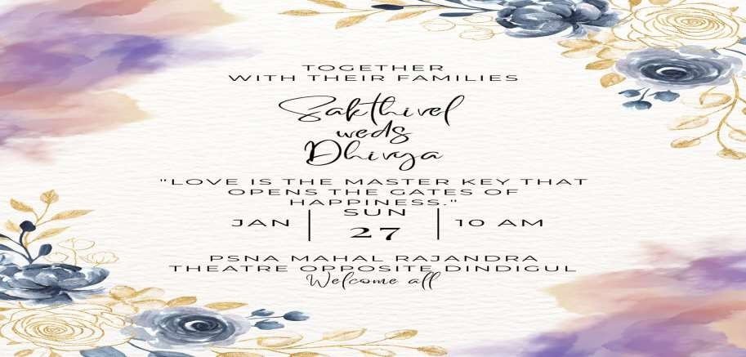

ADVATAGES & DISADVATAGES

Advatages

Student presentation and project and projects instanttly created in canva in canva. Being able to create simple comperhensive diagrams and throw ideas down in a virtual, collaorative space. The program will identify students talent and provide traning ultimately better caarreer

Disadvatages

Limitated number of free teplets Export setting are limited

Thedisadvantage of pre-fabricated in mural Netwok error to upload the lithub

APPLICATIONS

Canva is an online design tool that offers uaers the opportunting to create profesional- nlooking posters , slideshows, images, eventlyers, resumes, carde, certificates, inforgraphic, and other media .Our team designed invitation by using canva.

CONCLUSION

Thisthree step process facilitates a holistic approach to understanding, ideation, and exeution .Empathy mapping informs brainstoring sesion, and the insights gathused sever as a foundation for creting meaning ful canva projects. By integrating these elements, individuals and organigations can reat impact ful. Empathetic solutions that adderss real. Worls problems and connec with their intended audience on a deeper level.